Testing document for MS Decom activities

Project: z2f81_wpfis

System : xFE

CD: 151938.

Transport request: DFEK962733

—---------------------------------------------------------------------------------------------------------------------------------

1. myComp => Manage CFolder

Testing the changes in Fiori Development system. Opening the tile from Fiori launchpad.

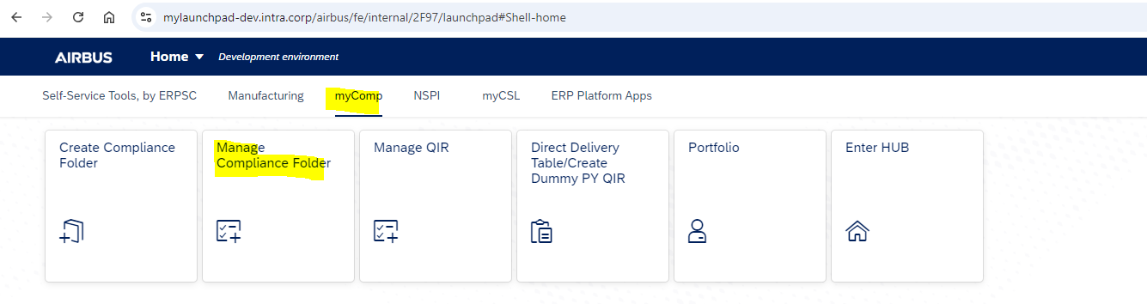

Search the data by using any filter values. Once results got fetched into table then click on the Export to my Drive button to export.

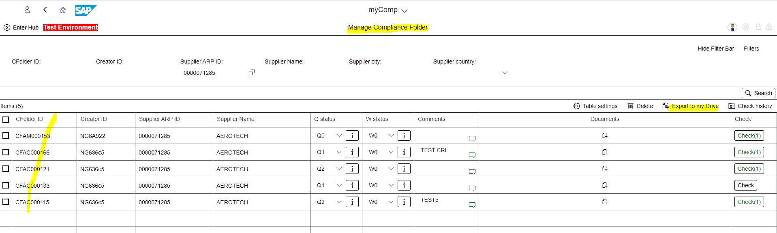

Below is the data exported successfully into gsheet.

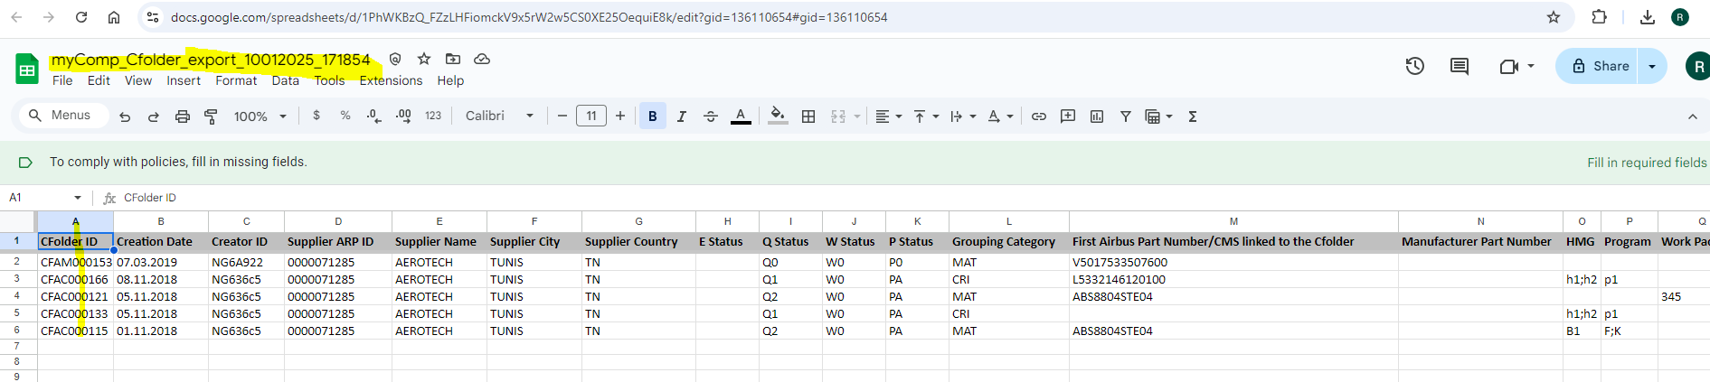

1. myComp => Manage QIR

Testing in Fiori Dev system.

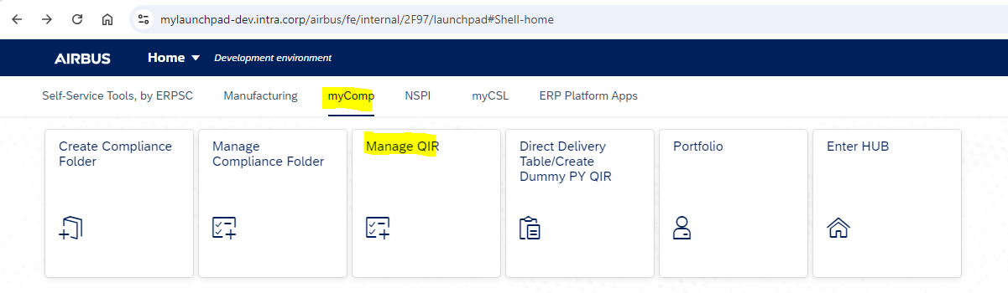

Search data by using any filters in fiori launchpad application and click on the Export to my Drive button.

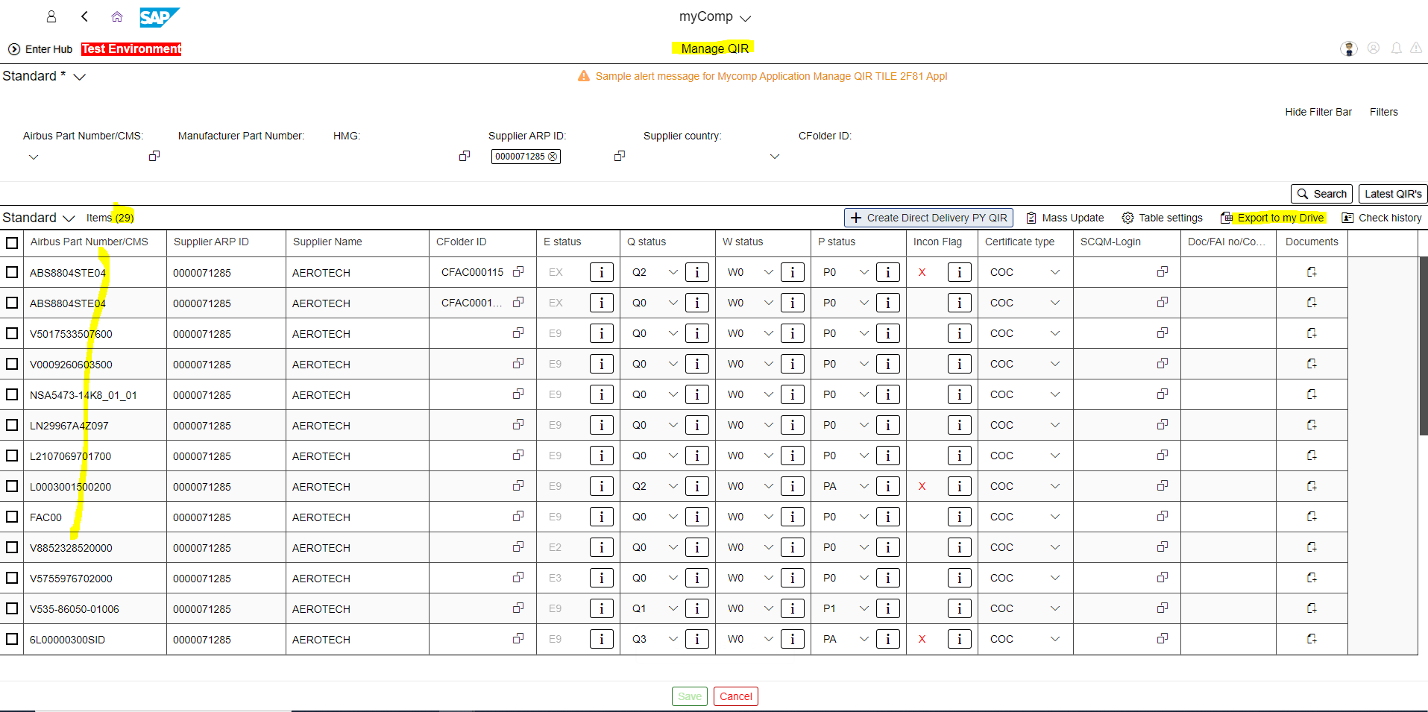

Below is the data successfully exported into gsheet.

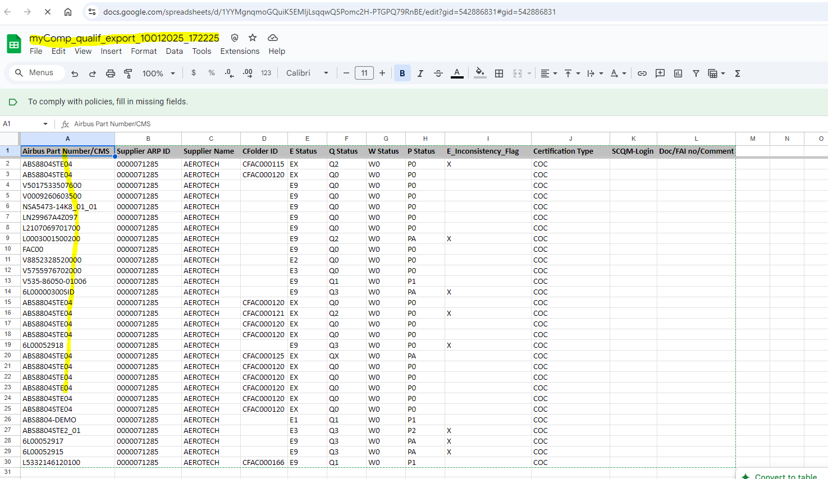

1. myComp => T2DD

Testing the application in Development Fiori launchpad by opening the respective tile.

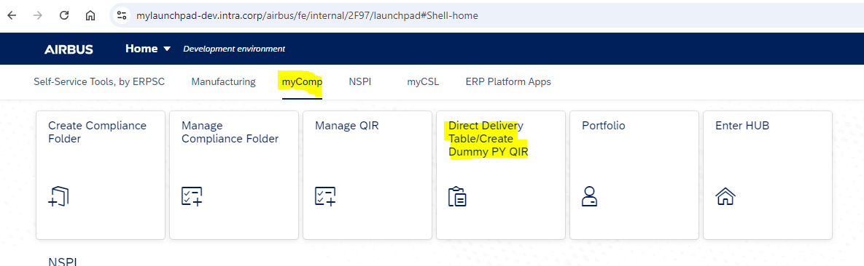

Fetch the data by using Search action and table will get populated with the data based on the selection criteria.

Once data retrieved successfully based on the filters, Click on the Export to my Drive button to export the data into gsheet.

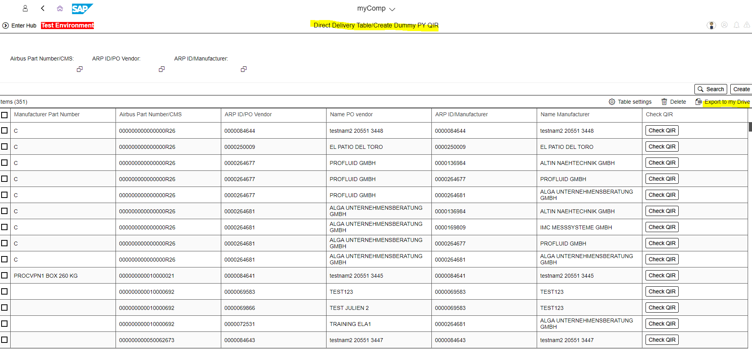

Below is the exported gsheet data.

